# POS Receipts

In order to avoid extensive data entry, it is required to extract the receipts within the existing BC instance and import the data into the ESO database.

## Creating the Receipts and Receipt Sections

Within the data extraction and loading package, Base Configuration, POS Frame Template folder there will be 3 SQL Scripts:

Step 1 - Extract from Source DB.sql - A script to extract all the data from the 4 receipt tables. The data is extracted into staging tables.

Step 2 - Insert Into Dest DB.sql - A script to insert the source data into staging tables within the ESO database. This script is re-created each time the data is placed into the source staging tables.

Step 3 - Create Receipts.sql - A script to insert the staging table data into the ESO database structures.

## Step 1 - Extract Source DB

Open an instance of SQL Server Management Studio and then open a new query window. Set the database to the main BC database.

Open and Execute the query “Step 1 - Extract from Source DB.sql”. This query will create a bc_extract tables in the custom integration database and populate the tables with the required receipt data.

Right Click on the custom integration database and navigate to tasks, generate scripts.

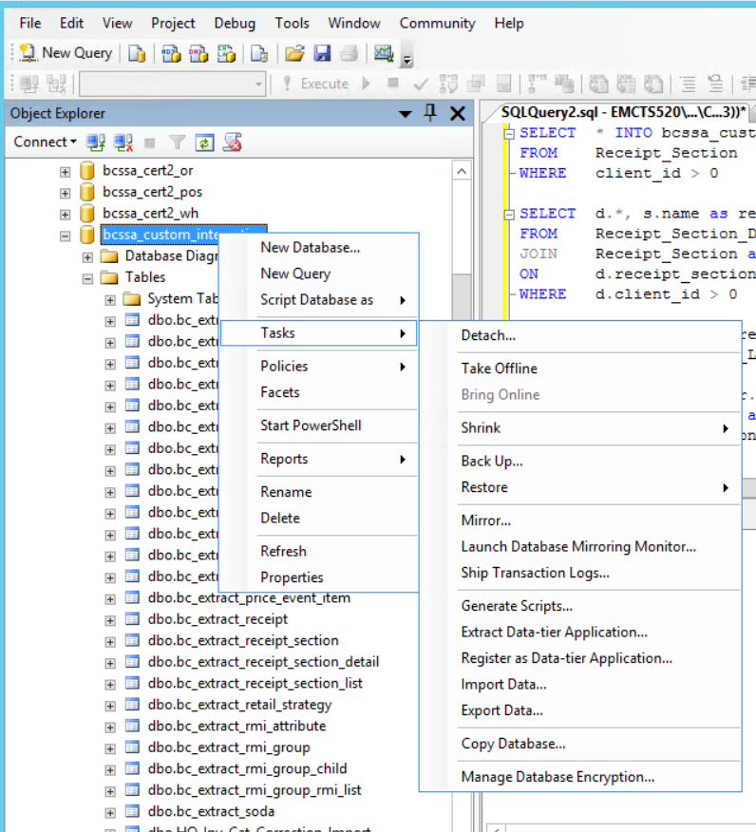

The script generation tool will be displayed.

Select the option to “Select specific database objects”. Expand the list of tables and select the following tables:

bc_extract_receipt

bc_extract_receipt_section

bc_extract_receipt_section_detail

bc_extract_receipt_section_list

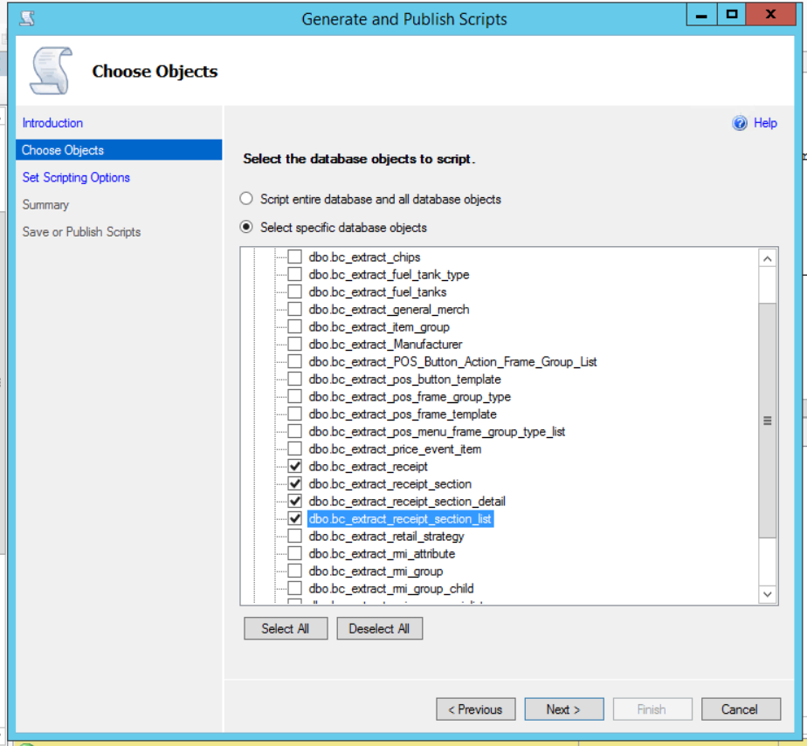

Click Next

The Scripting Options page will be display, Click on the Advanced button.

Set Include if NOT EXISTS to TRUE.

Set Schema Qualify Object Names to FALSE.

Set Script DROP and CREATE to TRUE.

Set Script USE DB to FALSE.

Set the “Types of data to script” to “Schema and data”.

Click OK.

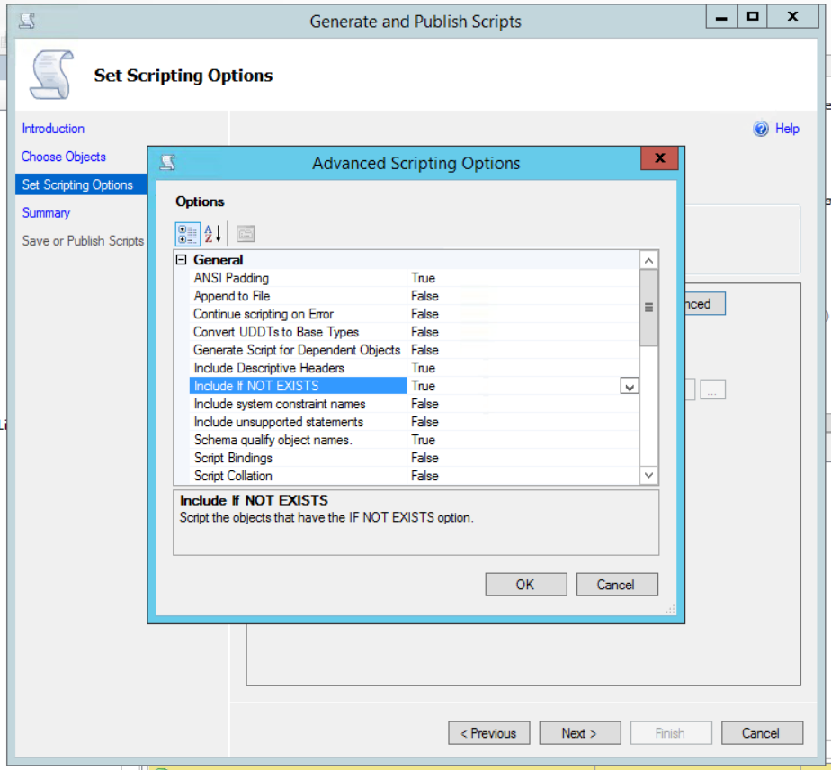

Set the option to “Save to Clipboard”. Click Next.

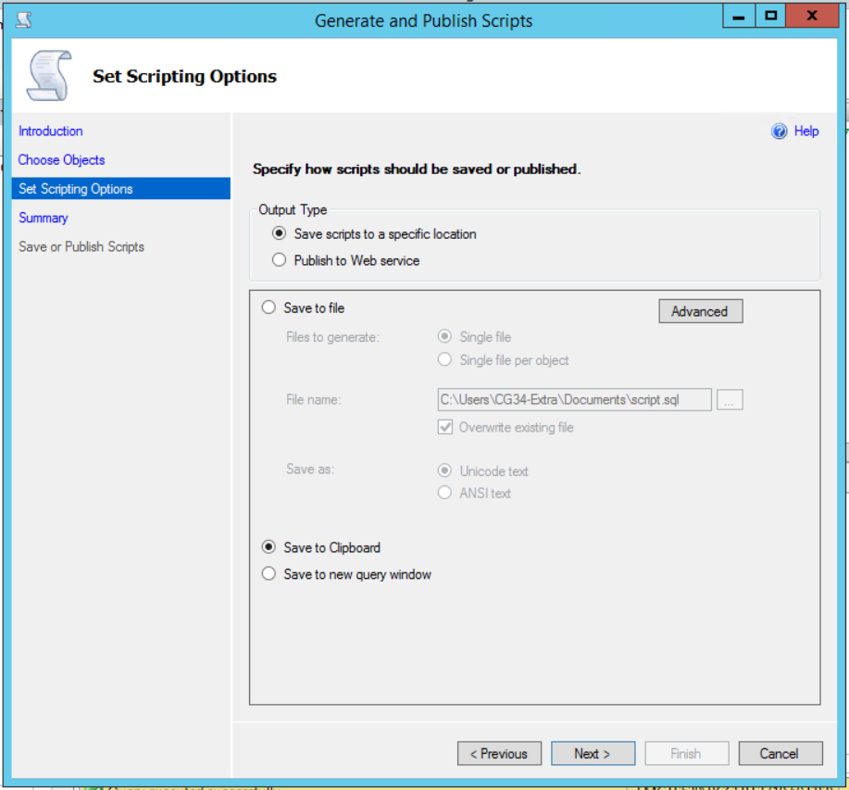

The Summary page will be displayed. Verify the information and Click Next.

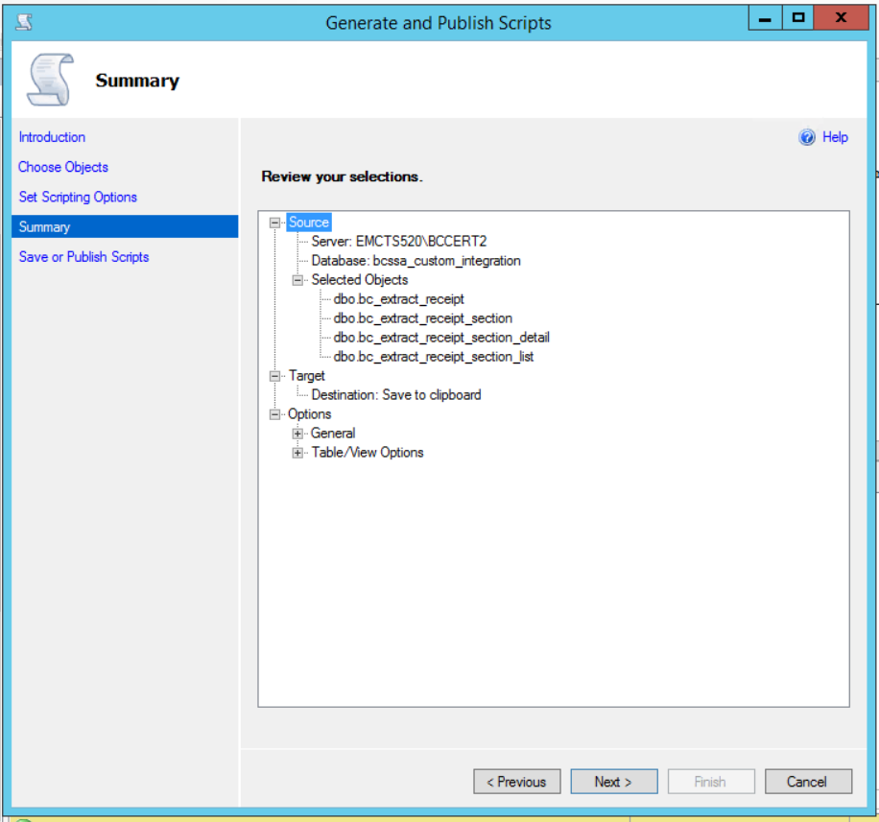

The Save or Publish Scripts page will be displayed. Verify the result and Click Finish. The page should disappear.

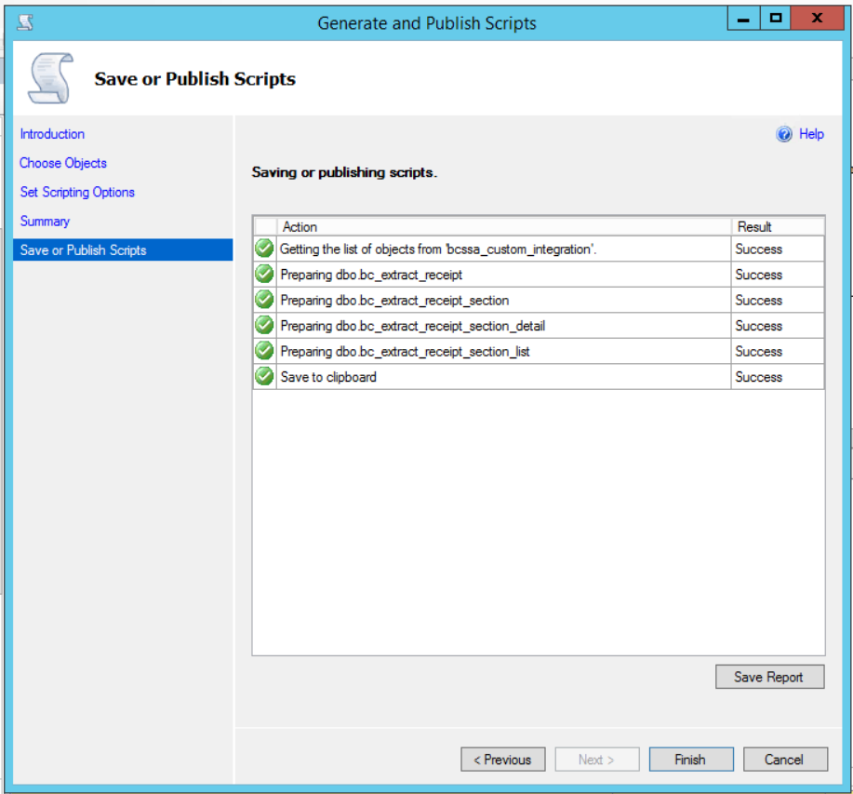

The contents of the script file are now on the clipboard.

## Insert the Destination DB.

Open the script “Step 2 - Insert Into Dest DB.sql” in a text editor. Select All and clear the contents of the script.

Select Paste to paste the information into the empty file.

Save the Query

Open an instance of SQL Server Management Studio and then open a new query window. Set the database to the main ESO database.

Execute the Query “Step 2 - Insert Into Dest DB.sql”

## Create the Receipts

Open an instance of SQL Server Management Studio and then open a new query window. Set the database to the main ESO database.

Execute the Query “Step 3 - Create Receipts.sql”.

Ensure that no errors and encountered and that data was inserted into the appropriate tables table.

## Clean up

If needed, go to both the source and destination databases and drop the following tables.

bcssa_custom_integration..bc_extract_receipt

bcssa_custom_integration..bc_extract_receipt_section

bcssa_custom_integration..bc_extract_receipt_section_detail

bcssa_custom_integration..bc_extract_receipt_section_list